**Hierarchy on Front Page:**

(top to bottom)

* HEADER including everything we decided in the diagram
* MAIN CONTENT (top to bottom)
  + Deals of the day / advertised / promoted spots (in the carousel)
  + Most popular (i.e ones that are being looked at the most right now)
  + Hot sales (the games that are the most played with good discount percentages)
  + Recommended for you (steam suggestions)
  + New Releases
* FOOTER (in no order, up to you how you structure this area)
  + Social media buttons
  + TOS, Privacy Policy, Cookie Policies.
  + Anything else that’s necessary, can’t think of anything.

**Advanced Search filters and how they could look?:**

* **Type:-** Games, Bundle (humble bundles), DLC’s
* **Genre:-** Simple dropdown with multi selects possible.
* **OS:-** Windows, Mac, Linux
* **Languages Supported:-** Square grids of their flags? Maybe simple icons instead of small icons. Up to you. There’s probably a lot, so don’t want it to be a gross drop long dropdown…
* **Companies:-** There’s going to be a lot. I don’t think there’s going to be a way around this. Look at GOG’s:

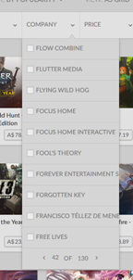

Could do something like this, but at the top (above the first item on that page of companies) we have a search bar, so people don’t have to scroll 30 pages to find the one they want. Evidently multi select.

* **Platforms:-** This is the platform of activation (i.e steam, uplay, origin etc). Maybe we continue with icons? Idk. There shouldn’t be too many of these, maybe 10? Your call.
* **Prices:-** Maybe a pricing slider like you mentioned. From free to the max price in that currency (we can handle this in the backend and just supply you the value). Or we can just do under $5, under $15, $40+ etc. Lets try both.
* **Listing filtering:-** We will need a separate dropdown to order by bestselling, price (low to high, high to low), A-Z ordering, highest discounts etc.

**Design of square listings:**

A combination of GOG and razer deals design

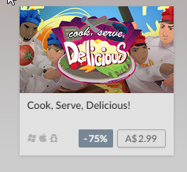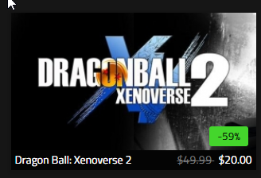

I like the way GOG (LHS) have done the separate box for game pricing and OS support and name. If we did the same but replace the -75% with a strikethrough of the maximum price (like razer deals have done) it would give the client a better representation of how much we’re saving them. Potentially look into doing the percentage too if we have enough space and it doesn’t cramp it up. Flynn had an idea of doing a popup box on click to display a bit more info at a quick glance (dialog box?). We can try this out too and see how it goes.